**C# Do-While Loop**

The C# *do-while loop* is used to iterate a part of the program several times. If the number of iteration is not fixed and you must have to execute the loop at least once, it is recommended to use do-while loop.

The C# *do-while loop* is executed at least once because condition is checked after loop body.

**Syntax:**

1. do{
2. //code to be executed
3. }while(condition);

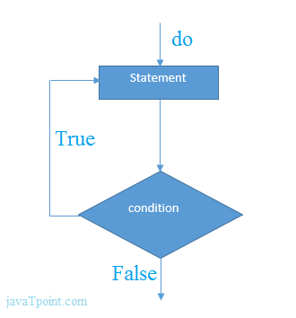

**C# do-while Loop Example**

Let's see a simple example of C# do-while loop to print the table of 1.

1. using System;
2. public class DoWhileExample
3. {
4. public static void Main(string[] args)
5. {
6. int i = 1;
8. do{
9. Console.WriteLine(i);
10. i++;
11. } while (i <= 10) ;
13. }
14. }

Output:

1

2

3

4

5

6

7

8

9

10

**C# Nested do-while Loop**

In C#, if you use do-while loop inside another do-while loop, it is known as nested do-while loop. The nested do-while loop is executed fully for each outer do-while loop.

Let's see a simple example of nested do-while loop in C#.

1. using System;
2. public class DoWhileExample
3. {
4. public static void Main(string[] args)
5. {
6. int i=1;
8. do{
9. int j = 1;
11. do{
12. Console.WriteLine(i+" "+j);
13. j++;
14. } while (j <= 3) ;
15. i++;
16. } while (i <= 3) ;
17. }
18. }

Output:

1 1

1 2

1 3

2 1

2 2

2 3

3 1

3 2

3 3

**C# Infinitive do-while Loop**

In C#, if you pass **true** in the do-while loop, it will be infinitive do-while loop.

**Syntax:**

1. do{
2. //code to be executed
3. }while(true);

**C# Infinitive do-while Loop Example**

1. using System;
2. public class WhileExample
3. {
4. public static void Main(string[] args)
5. {
7. do{
8. Console.WriteLine("Infinitive do-while Loop");
9. } while(true);
10. }
11. }

Output:

Infinitive do-while Loop

Infinitive do-while Loop

Infinitive do-while Loop

Infinitive do-while Loop

Infinitive do-while Loop

ctrl+c